Mrs Woodward

Passion for Fashion

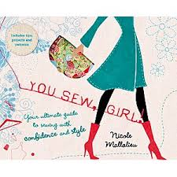

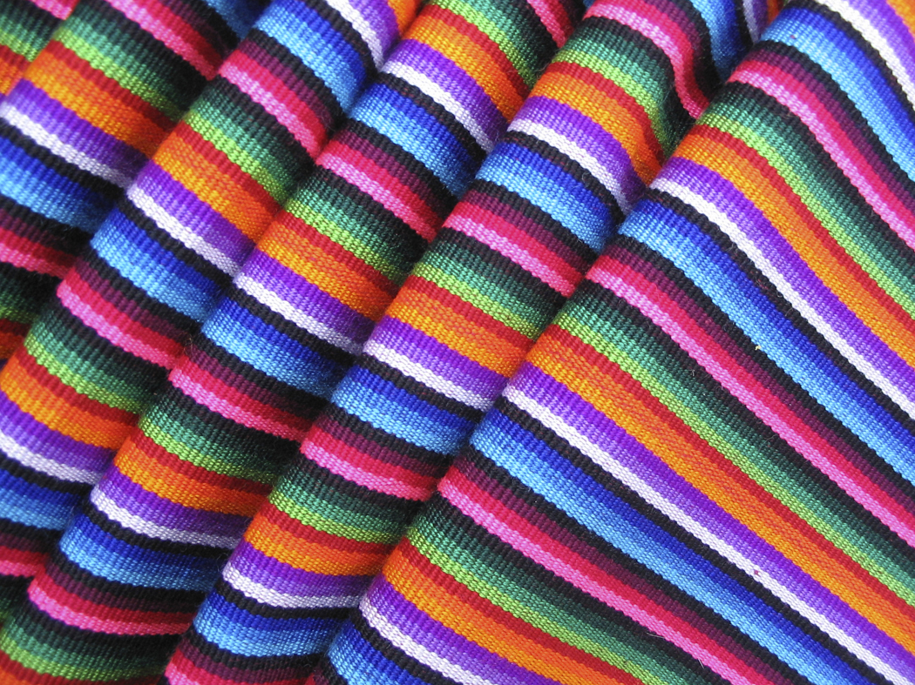

Week | Focus | ICT to assist learning
1 | - Voki to welcome students to Home Ec.  -Introduction to Home Ec - PowerPoint presentation on interactive whiteboard  -Use Bubble.us to brainstorm students ideas about home ec each student is given a colour and from their they do the think, pair, share.  -Think put their ideas in one colour  - Pair with a peer and share  - Share with whole class and Lm will place answers on interactive whiteboard  -Overview- Assessment – Access Website to view assessment details and criteria | Voki  Interactive Whiteboard  PowerPoint presentation  Bubbl.us  Student Laptops  Website
2 | -More detailed look at practical assessment task – What is a process journal? What is a design brief? Go to website to save assessment tasks and criteria sheets and access the example of a blog designed as an electronic form of a process journal.  - Start to research fashion history using web searches.  -Safety guidelines and rules in the sewing room which students will access from website  -Students to work on parts of a sewing machine- Have a worksheet Students must go to machines and label parts of the machine – go through answers on parts of the machine also on worksheet have some background information on the sewing machine Why it should be covered when not in use, where the bulk of material should be when sewing  -revision of safety and rules in the sewing room  -How to sew – Paper practice – Explaining that to do corners that the needle acts as a pivot point, for curvy lines always go slow and that the stitch length should always be at 2.5  -Homework for students to watch youtube clip how to thread a sewing machine singer simple Video - www.Repairsewingmachine.com - YouTube, (Flipped Classroom) explain how important it is to watch this clip as it will give them the knowledge to get their sewing licence. | Website – Assessment and resources  Student Laptops  Web searches  You tube clip
3 | - Students are to get cotton and bobbin and thread their machine – i will check to make sure they are threaded correctly  - Students will be given sample pieces of fabric and we will do some samplers which will consist of straight stitch, zigzag and over locking, side seam noting to students that side seams are always sown at 1.5cm , students will need to take photos of these samplers because they will need to place them on their blog/process journals. Explain what straight stitch is used for what zigzag is used for, when sewing seams the right sides of fabric should be together and the bulk of the material should be on the left of the machine, sewing on a button and students will be awarded with their sewing licence.  -Students will start to look more closely at the design brief of their practical assessment they will start to look at embellishments, on the website under the resources students will find YouTube videos for different embellishments  Textile fibres – Manmade and natural have fibre tree  Have various fabrics and fibres for the students to feel and touch and then we will group them as natural or manmade  - Look at Fabric and the properties of fabric selvedge, warp, weft, bias the straight grain | Website  YouTube
4 | - students will begin to Set up their individual blogs. They will research other blogs for fashion and begin to develop theirs for their process journals. Students set up individual BLOG (using scaffolded example)  - This BLOG will be implemented as a Process Journal. This Journal is the combination of ideas, information and data of any sort. Students are guided with what information is required for their process journals on their assessment sheets located on the website.  - Write down your thinking, explaining how you have made you informed choice.  - Include evidence that supports your decisions e.g. experiments, sketches, photos and brainstorming etc.  - This is where students will start a KWL chart. They can enter the what they already know and what they want to know and further through the unit they can complete the KWL with what they have learnt  - Students will be required to email their blog addresses to the LM so she can post on the class website. This will give students the opportunity to self assess, and also LM to provide feedback and peer feedback.  What is an embellishment? PowerPoint presentation Have samples to show students  - Start by looking at hand stitching – Make a felt monster hand stitching the edges  - yoyo’s and ribbon flowers with buttons in centre.  All Techniques show YouTube videos links on website  Student have the opportunity to make the above embellishments after LM’s demonstration and YouTube video | Search engines  Powerpoint  YouTube  Website  Blog/process journal
5 | -Start to work through the practical assessment task – Choose a design brief from either a bag or soft furnishing, then start researching fabrics, current fashions and colour trends  -students must make sure they are posting all of their thoughts and ideas as well as their choices in their blog/process journal  - After choosing some fabrics students must compare the fabrics using an exploratree.org.uk template, which they can access from the website. This activity helps students compare the fabric properties, the type of fabric, the purpose and is it suitable for their chosen design. Their results can then be posted on their blog/process journal.  – start their process journals, using polyvore for mood boards research design ideas on etsy. | Polyvore  Etsy  Website  Blog  Exploratree.org.uk
6 | Practical lessons  - Students to be working on exploring the materials and investigating how these can be manipulated  - Construct a collage of the design using the materials for the proper design (scan and upload onto BLOG)  - Teacher to be assisting students, offering guidance and feedback, and reviewing BLOG entries  - Students are to reflect in BLOG the design process  - Students draw their selected design, which is then photographed and uploaded onto the computer and opened into Photoshop where pictures, colours, textures and backgrounds can be imported into the design (Upload onto BLOG)  Work on magazine article use google to research fashion history of their chosen era | Blog  Photoshop  Digital camera  Google
7 | Looking at more embellishments and partake in demonstrations  - Tie Dye  - Bleaching  -Youtube video on class website  More research on current fashion trends, in season colours, and further work on the start of their process journals, designs, show student to use websites like polyvore, pantone upload all ideas and research into blog. | Youtube  Polyvore  pantone
8 | Practical lessons  - Teacher to be assisting students, offering guidance and feedback, and reviewing BLOG entries  - Students are to reflect in BLOG of progress thus far  Students also working on their magazine articles | Blog
9 | -Students to be working on their process journals/blog this is the final week for their journals  -need to be reflecting finishing off their KWL in blog, what have they learnt  -They also need to be working on their magazine article | Blog
10 | Magazine article and practical and process journal/blog due  Fun sewing activities this week  END OF TERM !!!!!!!!

